IPG 605/ IPG 1012/ IPG 1218
HV - IMPULSE GENERATOR

Surge testing 1.2/50µs 0.2-6.25 kV
0.2-10 kV
0.25-12 kV
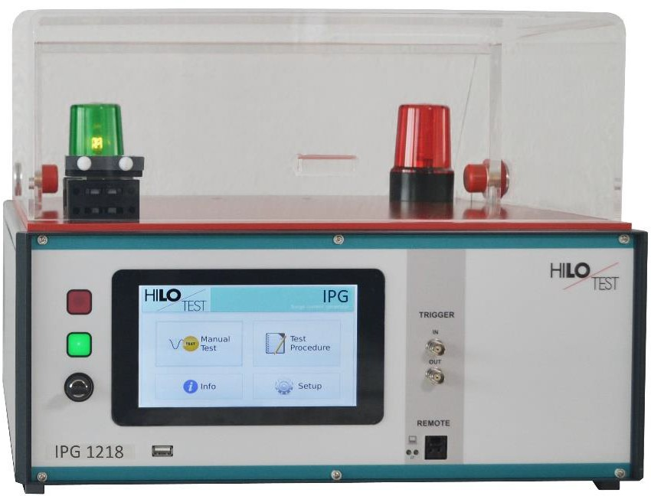
Picture: incl. Option PA 503

According to
IEC 60664 | Testing impulse dielectric strength of components, insulations, air- and surface flash-over gaps
VDE 0110
VDE 0411
VDE 0420
IEC 60335 : 2010 | Insulation test of inductors and coils

High-Voltage Pulse Generators IPG 1218 / 1012 / 605 generate standard impulse voltages with waveform 1.2 / 50 µs acc. to IEC 60060. They are designed for testing impulse dielectric strength of components, insulations, air- and surface flash-over gaps acc. to IEC.

The peak value of the test voltage is continuously adjustable from 0.2 - 6.25 / 10 / 12 kV. Positive or negative polarity of the output voltage can be selected. A built-in voltage divider 1000:1 allows monitoring of the impulse output waveform during testing.

The generators possess two high-voltage outputs with different source impedance. The HV output terminals are located beyond a dielectric cover with safety interlock. The transparent test cabinet prevents accidental contact with live threatening parts of the test object and allows observation of the test object during testing.

The generator output possesses a current monitor detecting breakdown or flashover of the test object. The threshold of the current monitor is adjustable.

The generator excels by its compact design, simple handling and precise reproducibility of test impulses. It features a microprocessor controlled user interface and a 7” touch screen unit for ease of use. The microprocessor allows the user to execute either standard test routines or a “user defined” test sequence. A standard USB port provides the ability to print a summary of the test parameters to a USB stick.

The software program IPG-REMOTE allows full remote control of the test generator via Ethernet light guide as well as documentation and evaluation of test results, accordingly to the IEC 17025. To record definite impulses, it is equipped with an Impulse Recording Function (IRF) Moreover all generator functions may be computer controlled via the isolated optical interface.

Options | IPG 605 IPG 1012 IPG 1218
PROTECTIVE COVER ON THE EQUIPMENT TOP
With safety interlock switch, connected to the safety interlock loop,  red and green warning lamps installed acc. VDE 0104 | See figure
Type PA 503, Dimensions W * H * D | 400 * 140 * 300 mm³
Type PA 505, Dimensions W * H * D | 400 * 250 * 400 mm³
Software IPG-REMOTE, for remote control
With Impulse Recording Function (IRF)
( XP, WIN7, WIN10 ) incl. 5m long light guide and PC Ethernet interface
Version without protective cover, current shunt Rm = 1Ω,
BNC for measuring on the back

TECHNICAL SPECIFICATIONS | IPG 605 | IPG 1012 | IPG1218
Mainframe
Microprocessor controlled touch panel | 7”, capacitive
Optical Ethernet Interface  for remote control of the generator | Optional
Interface for saving reports | USB
External Trigger input/ output | Switch/ 10V
Connector for external safety interlock loop | 24 V=
External red and green warning lamps | 24 V=, 40 mA
Mains power | 90V – 264V / 50/60 Hz
Dimensions of desk top case W * H * D | 450*180*500 mm3
Weight | 18kg
Generator section
Peak value of impulse output voltage, adjustable, ± 5 % | 0.2-6.25 kV | 0.2-10 kV | 0.25-12 kV
Waveform of impulse output voltage, acc. to VD 0433, IEC 60060 | 1.2/50 µs ± 30 % / 20 %
Max. stored energy | 5 Joule | 12 Joule | 18 Joule
Energy storage capacitor Cs | 0.25 µF
Resistor in series to the output HV1 Rs1 | 500Ω
Resistor in series to the output HV2 Rs2 | Standard 50Ω (opt. 40 oder 200Ω)
Output polarity, selectable | pos / neg / alt
Trigger :
a) manual | Push button
b) external Trigger input | Switch
c) internal, automatic, adjustable via test procedure | 1 - 1000 pulses
Repetition time, selectable | 1-1000 s | 3 -1000 s | 3 -1000 s
CURRENT SENSE | built-in
Threshold value, selectable | 1-830µAs | 1-1200 µAs | 1-1500 µAs
Impulse voltage divider, built-in | 1000:1 ± 2 %
Mains synchronous triggering, phase shifting, digitally selectable | 0 - 359°, step 1°
HV output, HV-OUT | HV connector
Accessories: power cable, turn key, instruction manual

